**Data Recovery**

1. Make a folder called **Data Migration Script** in your external drive or just copy the folder here and skip step two.
2. Ensure you have the Recover_Data, Restore_Recovered_Data, and import_pst.ps1
3. Run Recover_Data.bat
4. Type in your external drive’s drive letter.
5. Type in the user id of the person you want to save.
   1. Don’t know their ID? Check via C:\Users or ask them.
6. Wait for the script to finish.

**Example Recovery**

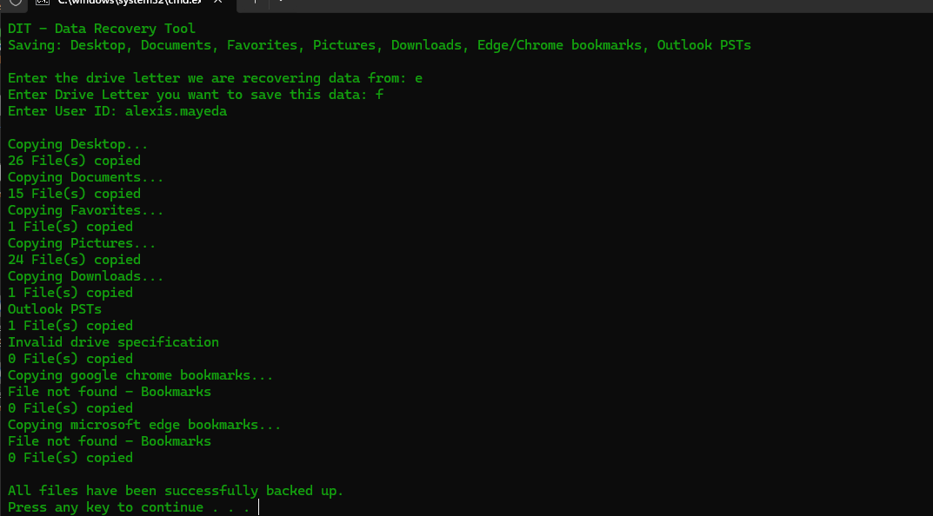

**Restoring Data**

1. Make sure the user has logged on to this computer at least once.
   1. If not, they will not have a profile on the PC to export this data to.
2. Restore_Recovered_Data.bat
3. Type in your external drive’s drive letter.
4. Type in the user id of the person you want to restore.
5. Wait for the script to finish.

**Example Restore**

